PRELIMINARY TECHNICAL PROBLEM REPORT IN UNIT AWA05
Sustained Drop in Water Production and Possible Ice Formation in the Cold Assembly
Document prepared for manufacturer technical review
Unit | SEAS AWA 05W
Operating location | Santa Catarina Palopó, Lake Atitlán
Telemetry node | Raspberry Pi + JSN-SR04T + WS-2000 weather station
Data reviewed | nivel_raw.csv, clima_raw.csv, statistical_analysis.json, and inspection photographs
Report date | May 28, 2026
Document status | Preliminary — does not replace manufacturer diagnosis or field refrigeration measurement

Scope note: This document does not present a definitive cause. It sets forth a technical hypothesis based on available evidence and defines specific questions for the manufacturer to confirm or rule out design, control, airflow, and refrigeration conditions.

1. Objective
This report documents the behavior of the AWA 05W unit during the recorded low-production streak, correlates the data with available meteorological and level records, and presents a verifiable technical hypothesis for consultation with the manufacturer. Observable findings are described, evidence-compatible conditions are identified, and parameter validation is formally requested from SEAS or its authorized representative.

The central hypothesis holds that the production drop may have been associated with ice formation in the cold assembly — specifically in the evaporator coil, copper tubing, and the area behind the dust filter. No determination is made as to whether the primary cause was the anti-icing control, airflow, refrigeration condition, refrigerant charge, evaporator sensor position, defrost sequence, or a combination of factors. Those aspects require direct review by the manufacturer.

2. Scope and Limitations
The analysis is based on local telemetry, photographic evidence, and the publicly available model specification. No refrigerant lines were opened, no pressure gauges were installed, no suction or discharge pressures were measured, superheat and subcooling were not determined, and evaporator temperature was not directly instrumented during the event. For these reasons, this document constitutes a preliminary technical characterization of the event and a structured consultation guide for the manufacturer — not a refrigeration fault determination.

Category | Description
Available | Reservoir volume, estimated production from positive increments, ambient temperature, humidity, dew point, pressure, wind, rainfall, and solar radiation.
Not available during the event | Evaporator temperature, suction/discharge pressure, compressor current, fan status, defrost status, and filter differential pressure.
Permitted conclusion | Documented production drop and subsequent visual evidence of ice in zones consistent with the evaporator/coil assembly.
Not permitted | Primary cause cannot be established without refrigeration circuit testing and review of the unit's control logic.

3. Technical Equipment Identification
The SEAS public data sheet for the AWA 05W describes a stationary atmospheric water generation unit with an R134a refrigeration cycle, nominal power of 0.8 kW, a 20 L internal tank, and a rated output of up to 50 L/day at 35 °C and 70% RH. The declared operating range extends from 7 °C / 90% RH to 50 °C / 10% RH. The published supply is 220 V ±10% – 50 Hz. The installed unit is assumed to operate at 220 V AC; this must be verified against the nameplate and serial number.

Model | SEAS AWA 05W
Function | Atmospheric water production through cooling and condensation
Rated output (published) | Up to 50 L/day at 35 °C and 70% RH
Refrigerant | R134a
Rated power | 0.8 kW
Internal tank | 20 L
Published operating range | 7 °C / 90% RH to 50 °C / 10% RH
Published power supply | 220 V ±10% – 50 Hz

4. Telemetry System Used for Analysis
The unit is equipped with a Raspberry Pi telemetry node. Level is measured ultrasonically via the JSN-SR04T sensor, and volume is estimated from the configured container geometry. The WS-2000 station delivers meteorological variables over HTTP, stored in clima_raw.csv. The processing pipeline converts units and generates operational indicators. This instrumentation is sufficient to detect production regime changes and external meteorological conditions, but does not directly measure the thermal state of the evaporator.

Layer | File / Element | Use
Level | data/raw/nivel_raw.csv | 1,811 records; volume calculated from ultrasonic distance readings.
Climate | data/raw/clima_raw.csv | 12,152 records; temperature, humidity, dew point, pressure, wind, rainfall, radiation, and UV.
Statistical analysis | statistical_analysis.json | Block B01 used as pre-event operational reference baseline.
Key limitation | No evaporator sensor | No direct measurement of coil freezing or copper tube temperature.

5. Baseline Behavior — Block 01
Block 01 is used as an operational reference reflecting normal production prior to the analyzed event. It does not correspond to the fault period; rather, it establishes the statistical baseline. The block covers level records from April 23, 2026 (12:29:11) through May 6, 2026 (09:27:12), and climate records through April 29, 2026 (06:13:50), with 100 hourly windows modeled. Total valid production was 347.93 L, and production per level day was 27.03 L/day.

Field | Value | Note
Level period | April 23 – May 6, 2026 | 12.87 days
Climate period | April 23 – April 29, 2026 | 5.74 days
Water records | 978 | Basis for volume change analysis
Valid climate records | 8,076 | B01 meteorological baseline
Total valid production | 347.93 L | After physical control of increments
Production per level day | 27.03 L/day | Reference scale

In B01, mean daily production was 28.99 L/day with a median of 31.38 L/day. Mean ambient temperature was 20.47 °C, mean relative humidity 72.02%, mean dew point 15.11 °C, and mean VPD 0.70 kPa. These values confirm that the unit produced water under temperate, humid ambient conditions, with no requirement for near-freezing temperatures.

Variable | Mean | Median | Maximum | Unit
Daily production | 28.99 | 31.38 | 38.82 | L/day
Relative humidity (B01) | 72.02 | 72.00 | 91.00 | %
VPD (B01) | 0.70 | 0.65 | 1.96 | kPa

6. Identification of the Low-Production Streak
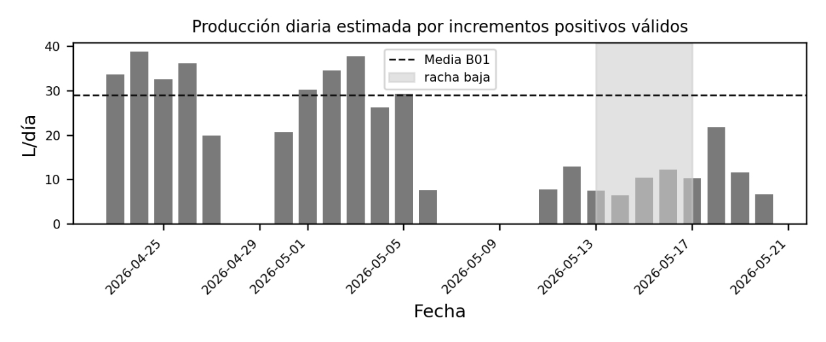
Estimated daily production was obtained by summing positive volume increments and discarding those exceeding 6 L as non-physical jumps for ordinary production. The series shows a prior regime of 26–38 L/day, followed by a drop to 6–12 L/day. The lowest complete production day was May 14, 2026, at 6.52 L/day. The low-production streak clearly begins on May 13, 2026, and persists through approximately May 17, 2026.

Figure 1. Estimated daily production. The shaded area marks the low-production streak.

Date | Estimated production
2026-05-01 | 30.18 L/day
2026-05-02 | 34.65 L/day
2026-05-03 | 37.80 L/day
2026-05-04 | 26.30 L/day
2026-05-05 | 29.35 L/day
2026-05-12 | 12.95 L/day
2026-05-13 | 7.54 L/day
2026-05-14 | 6.52 L/day
2026-05-15 | 10.51 L/day
2026-05-16 | 12.28 L/day
2026-05-17 | 10.29 L/day
2026-05-18 | 21.79 L/day

7. Critical Minimum Volume Period
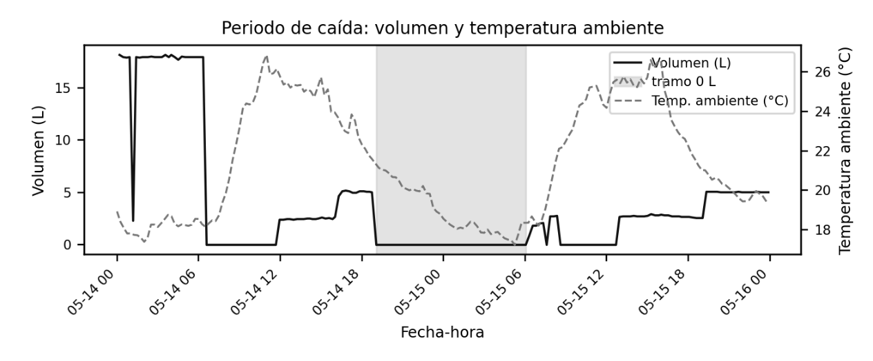
Within the low-production streak, an operational minimum interval was isolated between May 14, 2026 (19:04:03) and May 15, 2026 (06:03:34), during which the recorded volume remained at 0.00 L. The approximate duration of this interval was 10 hours 59 minutes. This period does not by itself confirm internal freezing, but it does document a severe loss of production or useful water accumulation. Applying a less strict threshold, the regime below 3 L extends through May 15, 2026 (19:03:50).

Figure 2. Measured volume and ambient temperature during the critical period.

Element | Value
Start of 0 L interval | 2026-05-14 19:04:03
End of 0 L interval | 2026-05-15 06:03:34
Approximate duration | 10 h 59 min
Extension below 3 L | Through 2026-05-15 19:03:50
Lowest daily day | May 14, 2026 — 6.52 L/day

8. Meteorological Conditions During the Critical Interval
The meteorological record closest to the start of the minimum corresponds to May 14, 2026 (19:04:27): ambient temperature 21.39 °C, relative humidity 71%, dew point 15.89 °C, wind 0.00 km/h, and rainfall 0.00 mm/h. Throughout the 0 L volume interval, ambient temperature remained between 17.11 °C and 21.39 °C. The event is therefore not explained by freezing outdoor air temperature.

Variable | Value at interval start
Climate timestamp | 2026-05-14 19:04:27
Ambient temperature | 21.39 °C
Relative humidity | 71%
Dew point | 15.89 °C
Calculated VPD | 0.74 kPa
Wind speed | 0.00 km/h
Hourly rainfall | 0.00 mm/h
Solar radiation | 0.00 W/m²

Meteorological statistics for the interval 2026-05-14 19:04:03 to 2026-05-15 06:03:34:

Variable | Mean | Min | Median | Max | Unit
Ambient temperature | 19.04 | 17.11 | 18.50 | 21.39 | °C
Relative humidity | 62.30 | 53 | 62.00 | 73 | %
Dew point | 11.66 | 8.39 | 11.50 | 16.39 | °C
Calculated VPD | 0.83 | 0.68 | 0.83 | 0.99 | kPa
Wind speed | 0.05 | 0.00 | 0.00 | 3.96 | km/h
Hourly rainfall | 0.00 | 0.00 | 0.00 | 0.00 | mm/h
Solar radiation | 0.12 | 0.00 | 0.00 | 4.26 | W/m²
Pressure | 24.99 | 24.95 | 24.99 | 25.03 | inHg

9. Field Inspection and Intervention
The low-production streak was detected through telemetry data, and the physical inspection was conducted approximately on the third day of the low-production condition — not on the first. Upon accessing the unit's interior, ice was observed on the evaporator coil's copper tubing, behind the dust filter, and in the cold zone adjacent to the water outlet/collection area. The unit was fully disconnected. After approximately four to five days with the unit powered off, a follow-up inspection revealed no visible ice. The unit was subsequently restarted and operated from approximately 09:30 to 19:00 with no visible ice formation observed during that window.

Stage | Description
Data detection | Low-production streak initiated around May 13, 2026, with daily minimum on May 14, 2026.
Physical inspection | Conducted approximately on the third day of low production.
Condition observed | Ice on copper coil tubing, behind the dust filter, and in the cold zone near the water outlet/collection area.
Intervention applied | Complete disconnection of the unit.
Follow-up observation | No visible ice after 4–5 days powered off.
Post-restart test | Unit observed operating from 09:30 to 19:00 with no visible ice during that window.

Figure 3. Internal view of the unit during inspection: visible ice on the cold assembly, coil, and tubing.
Figure 4. Detail of copper tubing with localized ice formation.
Figure 5. Additional detail of ice formation on tubing and coil assembly.

10. Preliminary Technical Interpretation
The available evidence is consistent with ice formation on the evaporator or on components directly associated with the cold assembly. The location of ice on the copper tubing and behind the dust filter directs attention toward the air-to-coil heat exchange, not solely toward the water outlet. That observation alone, however, is insufficient to attribute the cause to a specific component. Factors to be investigated include: insufficient airflow, restricted filter, intermittent fan operation, evaporator sensor out of position, inadequate defrost logic, low refrigerant charge, expansion restriction, or control conditions not anticipated in the original design.

The ambient telemetry does not support an explanation based on outdoor air temperature below 6 °C during the critical interval. Throughout the production minimum, the weather station recorded temperate ambient conditions. This points to a possible internal thermal condition: the evaporator may have dropped below 0 °C even with ambient air between 17 °C and 21 °C. That possibility requires direct evaporator temperature measurement and verification of the manufacturer's anti-icing control logic.

Hypothesis | Preliminary technical assessment
Insufficient airflow | Consistent with ice behind the filter and on the coil; requires verification of filter condition, fan operation, obstructions, and airflow rate.
Anti-icing / defrost control | Consistent if the unit does not cut the compressor or does not allow sufficient defrost time; requires manufacturer control parameters.
Evaporator sensor | Consistent if improperly mounted, out of calibration, or measuring a non-representative zone.
Refrigeration condition | Consistent with excessively low evaporation temperature; requires pressure gauges and superheat/subcooling calculation.
Drainage or collection | May affect useful water yield but does not independently account for ice on copper tubing.
Low ambient temperature | Not supported by critical-interval data; station recorded 17.11–21.39 °C throughout the event.

11. Technical Requests to the Manufacturer
The following technical parameter verifications are respectfully requested from the manufacturer, pertaining to the AWA 05W model and the recorded operating conditions. A response addressing specific design and control parameters is required — not a generic cleaning recommendation.

No. | Question or requested information
1 | Confirm the exact location of the evaporator sensor, the mounting method, and the acceptable reading range.
2 | Provide the anti-icing compressor cutout temperature, the restart temperature, and the hysteresis value.
3 | Describe the defrost sequence in full: compressor and fan behavior, duration, timing parameters, and lockout conditions.
4 | Provide the nominal airflow rate of the evaporator fan and the field verification method.
5 | Indicate the maximum allowable pressure drop across the dust filter and the technical criterion for cleaning or replacement.
6 | Provide expected suction and discharge pressures for R134a at ambient conditions of 17–22 °C and 60–75% RH.
7 | Provide the expected superheat and subcooling ranges for refrigeration circuit diagnosis.
8 | Confirm the nominal supply voltage for the installed unit, tolerances, and required protective devices.
9 | Confirm whether the unit supports an external start/stop contact, or whether external interruption must be performed via a properly rated contactor.
10 | Provide the recommended operating protocol when visible ice is observed on the coil or behind the dust filter.

12. Relay Evaluation and Preventive Control
An external relay-based control solution is under evaluation and must be treated as two separate concerns. On the logical side, the Raspberry Pi can issue a control signal or alarm when critical conditions are detected. On the electrical side, the unit operates at 220 V AC and cannot be switched directly by a low-voltage relay module. The actual power interruption must be performed using a properly rated contactor, overcurrent protection, an enclosed panel, and wiring installed by a licensed electrician.

The recommended architecture consists of: a Raspberry Pi on an independent power supply, an isolated GPIO output, a control relay or optocoupler, a power contactor rated for 220 V AC, thermal-magnetic protection, and a manual/automatic selector switch. The low-voltage relay only issues the command; it does not carry the main load. Before enabling automatic cutoff, it must be confirmed with SEAS whether the unit tolerates frequent external shutdown or requires its own shutdown sequence.

Element | Function
Raspberry Pi | Processes climate data, level, production status, and additional sensors as available.
Control relay | Low-voltage interface; must not directly interrupt the unit's power supply.
Contactor | Power-switching element for 220 V AC, specified and installed by a licensed electrician.
Breaker / disconnect | Overcurrent protection and safe isolation of the circuit.
Evaporator sensor | Recommended addition; enables real-time detection of freezing conditions before production drops.
Manual/automatic selector | Allows maintenance and manual operation independent of the control logic.

13. Intermittent Alert Program for Manual Shutdown
While the unit remains powered off or under observation, the Raspberry Pi can be kept operational on an independent power supply running a monitoring program. At this stage, reliance on automatic shutdown is not recommended until manufacturer validation is obtained. The initial phase should operate as an intermittent alert system for manual emergency shutdown and event logging.

The program operates through defined states: NORMAL, PRE-ALARM, CRITICAL, MANUAL SHUTDOWN REQUESTED, and UNIT OFF. Each transition must be logged to control_events.csv with a timestamp, the triggered rule, the measured value, the previous state, the new state, and operator confirmation. Alerts repeat until the operator confirms inspection or manual shutdown.

Condition | Proposed criterion | Action
Sustained low production | 12-hour production below 40% of B01 mean. | Intermittent alert and visual inspection.
Persistent zero volume | Volume = 0.00 L for more than 4 hours with unit presumed active. | Critical alert; evaluate manual shutdown.
Volume below 3 L | Persisting for more than 6 hours. | Severe production drop alert.
Evaporator near icing | Future sensor reading ≤ 1 °C for more than 5 minutes. | Manual shutdown request or validated preventive cutoff.
Safe restart | Evaporator ≥ 6–8 °C and minimum wait period elapsed. | Authorize restart; do not automate without validation.
Data failure | No climate or level data for two consecutive cycles. | Instrumentation alert; avoid blind automation.

14. Responsibility Boundaries
The integration must not merge telemetry software with electrical power switching without clearly defined responsibility boundaries. The Raspberry Pi may decide and log; it does not substitute for electrical protective devices or the manufacturer's refrigeration control criteria.

Responsible party | Scope
Telemetry / software | Alert rules, sensor readings, logs, dashboard, notifications, and low-voltage control signaling.
Licensed electrician | Contactor, breaker, 220 V AC wiring, enclosure, grounding, disconnecting means, and electrical testing.
Manufacturer / refrigeration technician | Anti-icing logic, fan, evaporator, sensor position, refrigerant, pressures, superheat/subcooling, and defrost sequence.
On-site operator | Visual inspection, manual shutdown, filter cleaning per procedure, and intervention logging.

15. Preliminary Technical Summary
The available data supports the hypothesis of ice formation in the cold assembly under non-freezing ambient conditions, but does not allow the primary cause to be established. The lowest-production period spans May 13 through May 17, 2026, with the daily minimum on May 14 and a 0.00 L volume interval running from May 14, 2026 (19:04:03) to May 15, 2026 (06:03:34). Ambient temperature throughout that interval was 17.11–21.39 °C. The subsequent inspection revealed ice on the copper coil tubing, behind the dust filter, and in the cold zone near the water outlet/collection area.

The case is presented to the manufacturer as an intermittent event consistent with evaporator or cold-assembly icing, accompanied by a severe production drop. Validation of anti-icing parameters, airflow, evaporator sensor condition, refrigeration status, and external control compatibility is formally requested. The relay/contactor solution is retained as a protective measure under evaluation — not as a root-cause correction. The recommended first step is deploying an intermittent alert system with documented manual shutdown; the automated phase should await technical and electrical validation.

16. Final comments
Technical review is respectfully requested from SEAS or its authorized representative for a SEAS AWA 05W unit, regarding an intermittent event consistent with ice formation in the cold assembly. Telemetry recorded a severe production drop beginning approximately May 13, 2026, with a daily minimum on May 14, 2026, and a 0.00 L volume interval from 2026-05-14 19:04:03 to 2026-05-15 06:03:34. During the critical interval, the weather station recorded ambient temperatures of 17.11–21.39 °C, mean relative humidity of 62.30%, and no rainfall. A subsequent inspection revealed ice on the evaporator coil's copper tubing, behind the dust filter, and in the zone adjacent to the water outlet/collection area. The unit was disconnected; after 4–5 days powered off, no visible ice was found. Upon restart, the unit operated from 09:30 to 19:00 with no visible ice observed during that window.

No primary cause is asserted. Validation is requested for the following: anti-icing control parameters, evaporator sensor location and calibration, defrost sequence, fan airflow rate, maximum allowable filter restriction, expected R134a operating pressures, superheat and subcooling ranges, and compatibility with an external start/stop contact or preventive cutoff via contactor. The unit is assumed to operate at 220 V AC, pending confirmation from the nameplate and serial number

